Ross Thyne

Thomas Collins

Charlie Nitschelm

Lucas Simmonds

Joseph Williams

ME 643

Deliverable 1

D

L4

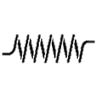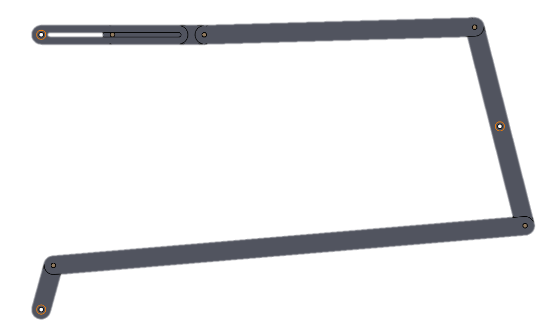

B

A

D

B

H

Xc

Yc

S

L32

L31

L2

L1

O

F

E

C

A

o

Figure #1: Problem Statement Diagram

# Constants and Calculations

## Constants

*Xc = 5 in*

*Yc = 2 in*

*H = 3 in*

*sx,start = 2.5 in*

*s = 1 in*

*L1 = 0.5 in*

*ωo = 50 rpm*

*k = 1 lbf/in*

## Geometry Calculations

*rAB = 5.160 in*

*rCD = 1.12 in*

*rBC = 1.12 in*

*rDE = 2.95 in*

*rEF = 2.5 in*

*rOA = L1*

*rFO = H*

*mE = 0.05 slugs*

## Calculations

### Loop Definitions

Loop 1: *L1 + L2 + L31 - OC = 0*

Loop 2: *OC + L32 + L4 – S – OF = 0*

### Loop Parametrization

Loop 1

*ROA + RAB + RBC – RCO = 0*

*ROA = rOA {cosθ, sinθ}*

*RAB = rAB {cosθA, sinθA}*

*RBC = rBC {cosθB, sinθB}*

*RCO = {XC,YC}*

Loop 2

*ROC + RCD + RDE - REF - RFO = 0*

*RCD = rCD {cosθB, sinθB}*

*RDE = rDE {cosθD, sinθD }*

*REF = rEF {1, 0}*

*RFO = rFO {0, 1}*

### Position Loop Equations

Loop 1

*rOAcos(θ) + rABcos(θA) + rBCcos(θB) – XC = 0 (X)*

*rOAsin(θ) + rABsin(θA) + rBCsin(θB) – YC = 0 (Y)*

Loop 2

*XC + rCDcos(θB) + rDEcos(θD) – rEF = 0 (X)*

*YC + rCDsin(θB) + rDEsin(θD) – rFO = 0 (Y)*

θA, θB,θD, and rEF are the unknowns to be solved. Taking the derivative of the position equations above with respect to time we get velocity equations.

### Velocity Loop Equations

Loop 1

*-rOAsin(θ) - rABAsin(θA) - rBCBsin(θB) = 0 (X)*

*rOAcos(θ) + rABAcos(θA) + rBCBcos(θB) = 0 (Y)*

Loop 2

*-rCDBsin(θB) - rDEDsin(θ D) -EF = 0 (X)*

*rCDBcos(θB) + rDEDcos (D) = 0 (Y)*

Where A,B,D, andEF are our unknowns to be solved for. Taking derivative of the velocity equations above with respect to time we get our acceleration equations.

### Acceleration Loop Equations

Loop 1

*-rOAsin(θ)-rOA2cos(θ) - rABAsin(θA) - rAB2cos(θA) - rBCBsin(θB) - rBC2cos(θB) = 0 (X)*

*rOAcos(θ) -rOA2sin(θ) + rABAcos(θA) - rAB2sin(θA) + rBCBcos(θB) - rBC2sin(θB) = 0 (Y)*

Loop 2

*-rCDBsin(θB) - rCD2cos(θB) - rDEDsin(θ D) - rDE2cos(θ D) -EF = 0 (X)*

*rCDBcos(θB) - rCD2sin(θB) + rDEDcos(θ D) - rDE2sin(θ D) = 0 (Y)*

Where A,B,D, and EF are our unknowns to be solved for. The forces on each pin were then determined mathematically by using MATLAB.

### Distance Definitions

To calculate the axial and transverse force we needed to project the forces onto x and y axis

Loop 1

A

A

B

B

Loop 2

B

B

D

D

### Forces on Pins

Member OA

$$F_{Ax}+F_{Ox}=0$$

$$F_{Oy}+F_{Ay}=0$$

$$M_{O}+ F_{Ay}∙R_{OA, y }- F_{Ax}∙R_{OA, x}- F_{Ox}∙R_{OA, y }+ F_{Oy}∙R_{OA, x }=0$$

Member AB

$${-F}_{Ax}+F_{Bx}cosθ_{B}=0$$

$${-F}_{Ay}+F_{Bx}sinθ_{B}=0$$

$$- F_{Ax}∙R_{AB, x }- F_{Ay}∙R_{AB, y}- F_{Bx}∙R_{AB, x }+ F_{By}∙R_{AB, y}=0$$

Member BC

$$F_{Cx}-F_{Bx}+F_{pin,x}=0$$

$$F_{Cy}+F_{By}+F_{pin,y}=0$$

$$F_{Bx}∙R_{BC, x }- F_{By}∙R_{BC, y}- F_{Cx}∙R_{BC, x }+ F_{Cy}∙R_{BC, y}=0$$

Member CD

$$-F_{Cx}+F_{Dx}=0$$

$$-F_{Cy}+F_{Dy}=0$$

$$- F_{Cy}∙R_{CD, x }- F_{Cx}∙R_{CD, y}- F_{Dy}∙R_{CD, x }+ F_{Dx}∙R_{CD, y}=0$$

Member DE

$$k_{spring}(2-R_{OE, x})-F_{Dx}-m_{E}∙a_{E}=0$$

$$F_{N}+F_{Dy}-F_{G}=0$$

# Figures



Figure #2: Trajectories of points A, B, D, and E



Figure #3: X position of points A and E Vs crank angle



Figure #4: X component of linear velocities of points A and E Vs crank angle



Figure #5 X component of linear acceleration of points A and E with the magnitude of linear accelerations of CM of members 1,2,3,4 Vs crank angle



Figure #6 Magnitude in joints O, A, B, C, D and E Vs crank angle

**Free Body Diagrams of Members #1-5**

Member #1.

FAy

y

FAx

x

M1

FOx

O

FOy

Member #2

y

F12

F32

x

Member #3

F43

y

x

FC

F23

Member #4

y

F34

x

F45

Member #5

y

F45

x

FS

FN

FG

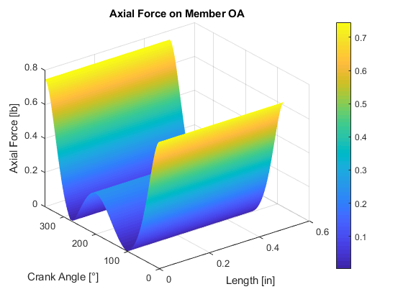

Figure #7: Axial force on member OA.

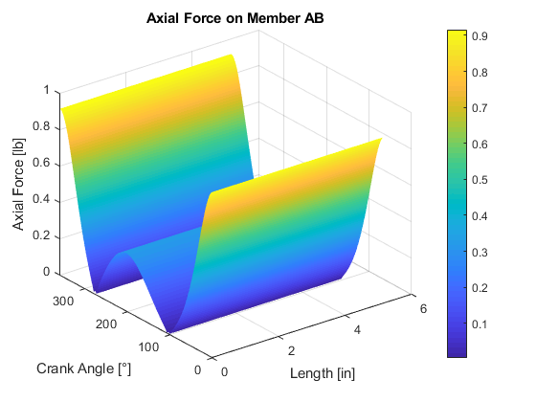

Figure #8: Axial force on member AB.

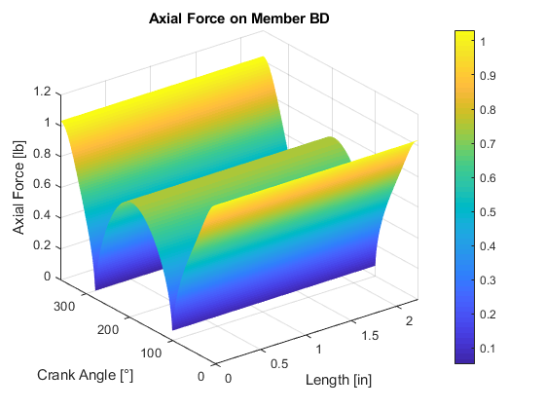

Figure #9: Axial force on member BD.

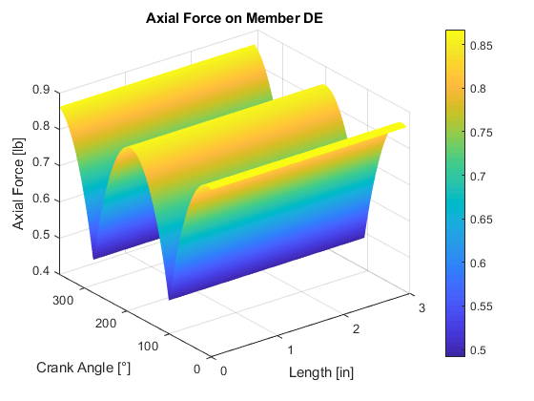

Figure #10: Axial force of member DE.

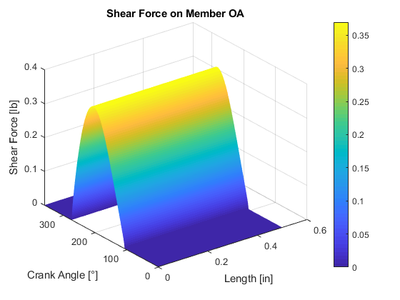

Figure #11: Shear force on member OA.

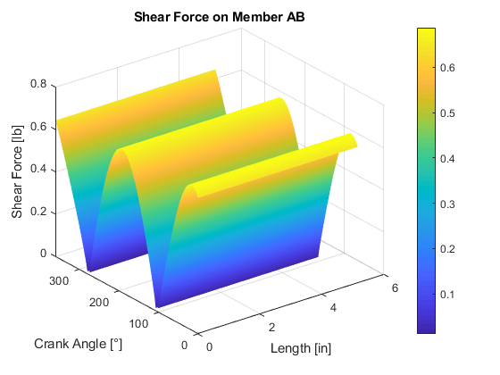

Figure #12: Shear force on member AB.

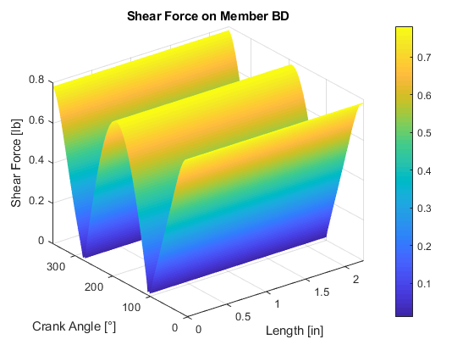

Figure #13: Shear force on member BD.

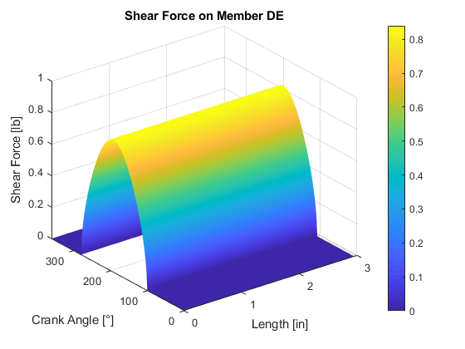

Figure #14: Shear force on member DE.

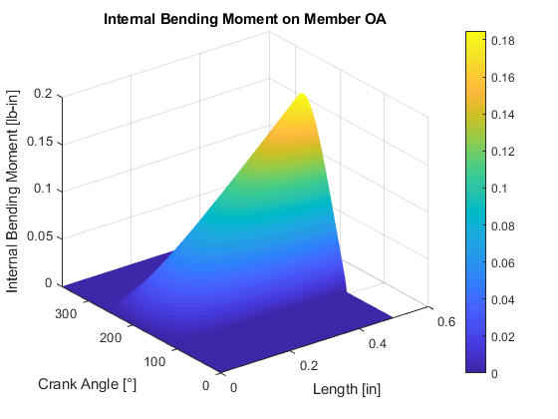

Figure #15: Internal bending moment on member OA.

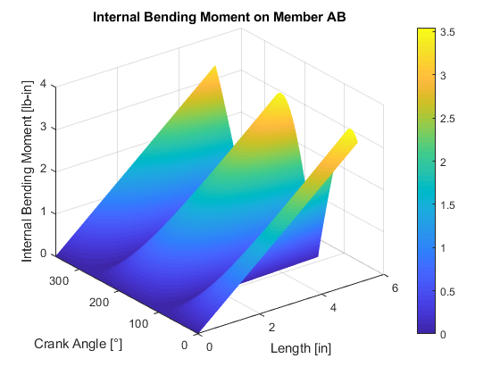

Figure #16: Internal bending moment on member AB.

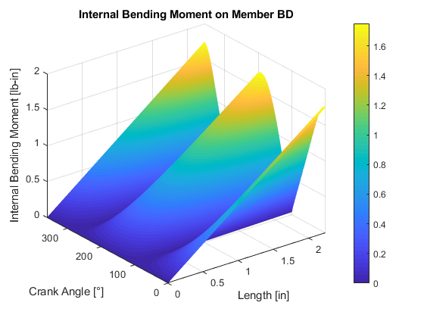

Figure #17: Internal bending moment on member BD.

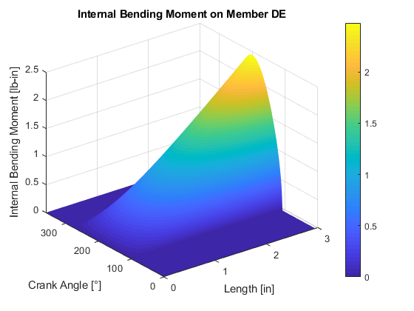

Figure #18: Internal bending moment on member DE.

# Critical Values

|  |  |
| --- | --- |
| **Member** | **Force (lb)** |
| Max Axial OA | 0.745 |
| Max Axial AB | 0.916 |
| Max Axial BD | 1.031 |
| Max Axial DE | 0.867 |
| Max Shear OA | 0.370 |
| Max Shear AB | 0.687 |
| Max Shear BD | 0.782 |
| Max Shear DE | 0.840 |
| Max Moment OA | 0.185 lb in |
| Max Moment AB | 3.545 lb in |
| Max Moment BD | 1.751 lb in |
| Max Moment DE | 2.477 lb in |
| Min Axial OA | 0.002 |
| Min Axial AB | 0.004 |
| Min Axial BD | 0.052 |
| Min Axial DE | 0.491 |
| Min Shear OA | 0.000 |
| Min Shear AB | 0.012 |
| Min Shear BD | 0.011 |
| Min Shear DE | 0.000 |
| Min Moment OA | 0.000 lb in |
| Min Moment AB | 0.000 lb in |
| Min Moment BD | 0.000 lb in |
| Min Moment DE | 0.000 lb in |

|  |  |
| --- | --- |
| **Pin** | **Max Force (lb)** |
| O | 0.561422 |
| A | 0.561422 |
| B | 1.059321 |
| C | 0.75069 |
| D | 0.593995 |
| E | 0.567541 |

# Results

From the compiled list of critical values of the dynamic system, the maximum axial force occurs in member BD of our system, whereas the minimum occurs in OA. From the shear stress calculations, the maximum value occurs in member DE, and minimum value, zero, occurs at various orientations of members OA and DE. The largest bending moment is in the longest member, AB, while all members exhibit the ability to operate without a bending moment at set orientations.

For the connections, pins O and A exhibit the same values, as member OA is a two force member with equal and opposite axial forces at each connection. These pins also exhibit the lowest maximum load. The connection at point B will need to be the sturdiest in our system, as it endures almost twice as much of a maximum load as pins O and A.